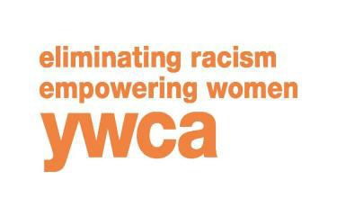
APPLICATION FOR EMPLOYMENT 1701 S. 17th St Suite 2D Lincoln, NE 68502
(402) 434-3494

Date: Position(s) for which you are applying:

Name: Last First M.I.

Address: City, State, Zip:

Home Phone: ( ) Work Phone: ( )

E-Mail Address:

Are you legally authorized to work in the United States? Yes No Have you ever worked for a YWCA in the past? Yes No
If yes, where and when?

Have you ever been convicted of a crime in any jurisdiction*? Yes No

If yes, please explain:

* A conviction does not absolutely bar consideration for employment, but rather is taken into account in light of the specific job requirements.

EXPERIENCE: List your last three (3) employment positions. Indicate your current or most recent experience first.

Position: Dates employed:

Employer’s name and address:

Supervisor’s name: Phone number:

Final salary: Reason for leaving:

Major responsibilities:

Position: Dates employed:

Employer’s name and address:

Supervisor’s name: Phone number:

Final salary: Reason for leaving:

Major responsibilities:

Position: Dates employed:

Employer’s name and address:

Supervisor’s name: Phone number:

Final salary: Reason for leaving:

Major responsibilities:

OPTIONAL: | Please attach additional employment history or volunteer experience on an | Working to empower women and eliminate racism
 | experience on an additional page.

EDUCATION: Name & address Major study Degree or credits

High School:

College:

Post graduate/other:

TRAINING: List any additional applicable training.

SKILLS: Indicate your skills and interests applicable to this position.

ACTIVITIES: List activities and current professional membership(s) applicable to the position for which you are applying. *

*If you prefer, you need not list any organization or activity, which might indicate the race, color, creed, religion or national origin of its members.

How did you hear about employment opportunities at the YWCA? _________________________________________________

EMPLOYMENT REFERENCES: Please name three (3) persons who have definite knowledge of your employment history. Name Address City, State, Zip Phone Number Position

I understand that any misstatement or omission of information on this application will be sufficient reason for rejection of my application or termination of employment, if hired. In addition, I authorize the references listed above and any former employers to provide you with any and all information concerning my previous employment and any information they may have and release all parties from all liability for giving any information within their knowledge or record.

Signature:
Date:

The YWCA is an equal opportunity employer.

